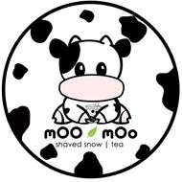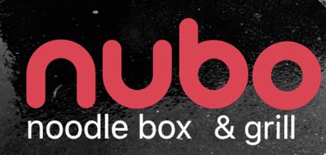

Coming soon to Elk Grove will be a mOO mOo and nubo collaboration. Calvine mOO mOo tea house will specialize in various milk teas, flavored teas, and blended drinks. Nubo will be a noodle box and grill restaurant that serves noodles with various protein options, fresh vegetables, and signature dressings.

Description
Crew members get to learn about and work at a variety of work stations: Prep, Grill, Drinks, and Take-Out. Crew Members' responsibilities require them to be on their feet working while clocked in, unless on break. If they are not busy, they are expected to take on tasks they see that need to get done, and pitch in to help their teammates.
In addition to following mOO mOo policies and procedures, principle responsibilities include, but are not limited to:

- Food Prep:
- Following recipes accurately and performing food preparation processes such as cooking, marinating, seasoning, grilling meats, chopping/dicing/cutting herbs, fruits, and vegetables.
- Completing hot and cold food preparation assignment accurately, neatly, and in a timely fashion.
- Maintaining appropriate portion control and consistently monitoring food/drink levels on the line.
- Maintaining proper food/drink handling, safety, and sanitation standards while preparing food and drinks.

- Customer Experience
- Providing friendly, quality customer service to each customer.
- Working toward understanding and articulating food with integrity.
- Maintain a professional appearance at all times and display a positive and enthusiastic approach to all assignments.
- Be able to exhibit a cheerful and helpful attitude, and provide exceptional customer service.
- Be able to adapt to changing customer volume levels with a sense of urgency.
- Have the ability to demonstrate a complete understanding of both menus

- Miscellaneous:
- Consistently and accurately using prep sheets, cleanliness list, and station checklists.
- Cleaning equipment, as assigned, thoroughly in a timely fashion.
- Washing cookware and utensils throughout the day.
- Work as part of a team by helping others as needed or requested.
- Be able to follow instructions for recipes and sanitation guidelines.
- Have the ability to cross-trained in all areas of the kitchen and line.

At mOO mOo, we don't have multiple job titles for our entry level employees but all of our crew will play the role of dishwasher, server, cashier, barista, cook, prep cook, etc., so be prepared to learn and work hard if you join us.

